**Term Project Documentation**

**Project Description:**

The Elevator Control System with a Real-Time Operating System (RTOS) is a sophisticated project designed to enhance the efficiency, safety, and reliability of elevator operation. This project aims to create a responsive and robust elevator control system that can efficiently manage elevator operations while ensuring the safety of passengers and compliance with building codes and regulations. Some of the main functions include an Up and Down button at each floor as well as a current floor indicator.

**Console Components:**

1. A status window that would include which floor the elevator is on.
2. A CLI will include commands such as:
   1. Selecting which floor the user wants to go to when the user is inside the elevator.
   2. Selecting whether the user wants to go up or down when the user is outside the elevator.
   3. Place the elevator in maintenance mode.
3. An external pushbutton that will emergency stop the elevator.

**Tasks & ISR’s:**

Tasks

1. Elevator Position Task
   1. Will update the status window with the current idle position of the elevator.
2. Maintenance Task
   1. Will place the elevator system in maintenance mode ensuring that it is currently unable for use.
3. Exterior Control Task
   1. Will include any exterior controls for the elevator that will allow the user to request the elevator to go up or down.
4. Interior Control Task
   1. Will include any interior controls for the elevator that will allow the user to request the floor, emergency stop or maintenance mode.

ISR’s

Main Interrupt:

* USART Interrupt used by the on-board blue USER button on the MCU

Secondary Interrupt:

* External pushbutton which when pressed will stop the elevator in the case of an emergency

State Machine Diagram:

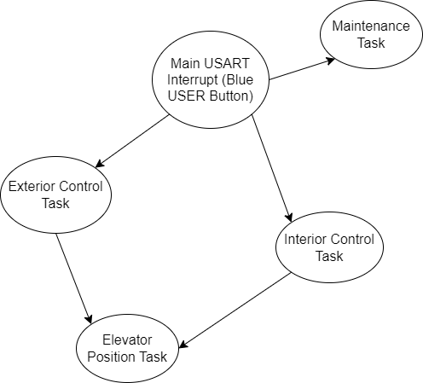

ISR State Machine Diagram:

